SIMATS ENGINEERING ASSESSMENT TOOL 3

COURSE NAME: INTERNET PROGRAMMING COURSE CODE: CSA4303

N. Murali sai (192372309)
Marks: 91

COURSE OUTCOME COVERED

CO-1: Develop well-structured, standards-compliant web pages using HTML/XHTML and XML, and apply Internet protocols and HTTP communication mechanisms for web content delivery. (L2)

Assessment Tool: Code along exercise: Make your first HTML page together with CSS

Weightage: 10%

QUESTIONS: Total Marks: 10

Scenario: Web Development Standards Implementation

A start up is developing a modern web application. During development, the team encounters multiple issues related to HTML elements, HTTP methods, XML syntax, and web communication protocols.
The following observations are made:

● The team needs to embed a promotional video on the homepage. ● A registration form must securely send user data to the server.
● The navigation menu must follow semantic HTML standards.
● XML configuration files are being used but contain syntax errors. ● The application must communicate over the correct web protocol.

Data Snippets Provided

Snippet 1: Video Embedding Options A. <media src="video.mp4"></media>
B. <video src="video.mp4" controls></video>

C. <movie src="video.mp4"></movie> D. <vid src="video.mp4"></vid>

Snippet 2: Form Submission Methods

A. GET B. POST C. PUT D. DELETE

Snippet 3: Navigation Elements

A. <div> B. <nav>
C. <section> D. <header>

Snippet 4: XML Syntax

A. <note><to>User</to><from>Admin</from>
B. <note><to>User</to><from>Admin</from></note> C. <note><to>User</from></note>
D. <note to="User"></note

Snippet 5: Web Communication Protocols

A. FTP B. HTTP C. SMTP D. SNMP

Questions:

1. Select the correct HTML tag for video embedding and justify your answer.

2. Identify the appropriate HTTP method for form submission and explain why. 3. Choose the proper semantic element for navigation and justify its usage.
4. Identify the correct XML syntax and explain the error in other options.

5. Choose the correct protocol for web communication and justify your choice.

Code of Conduct:

I N. Murali Sai (192372309) certify that this submission is my original work and that I have adhered to the guidelines specified for this assessment.
I understand that any violation of academic integrity rules will result in disciplinary action.

Signature of the student:
Murali sai

RUBRICS FOR CALCULATION:

Criteria | Weightage | Level 4 – Exemplary | Level 3 – Proficient | Level 2 – Developing | Level 1 – Beginning
Understanding of Case | 23 | Thorough understanding; clearly identifies all key issues | Good understanding with most issues identified | Basic understanding; some issues missed | Poor understanding; problem not identified correctly
Application of Concepts | 23 | Effectively applies relevant concepts to analyze the case deeply | Applies appropriate concepts with minor gaps | Limited application of concepts | Fails to apply relevant concepts
Analysis | 18 | In-depth analysis with strong reasoning and insights | Good analysis with logical reasoning | Basic analysis with limited depth | Weak or no analysis; lacks reasoning
Solution Design | 18 | Innovative, feasible solutions with strong justification | Logical solutions with adequate justification | Basic solutions with weak justification | Incorrect or no solution provided
Clarity | 9 | Clear, well-structured, and easy to understand | Organized and understandable presentation | Limited clarity and structure | Poor clarity; difficult to understand

QUESTION 1
Select the correct HTML tag for video embedding
ANSWER  Option B | <video src="video.mp4" controls></video> is the only valid HTML5 element for embedding video.

Why it is correct
- <video> is a standard HTML5 element defined in the W3C/WHATWG specification; browsers natively know how to decode and play it, so no plug-in (such as Flash) is needed.
- The src attribute points to the media file, and the controls attribute shows the built-in play/pause, volume, seek bar and full-screen buttons.
- Fallback text can be placed between the tags for older browsers, and width, height, poster, autoplay and loop add more control.
Why the others fail
Option | Tag | Verdict
A | <media> | Not an HTML element – ignored by browsers
B | <video> | Valid HTML5 element – plays video
C | <movie> | Not an HTML element – ignored by browsers
D | <vid> | Not an HTML element – ignored by browsers

Code used
<!DOCTYPE html>
<html lang="en">
<body>
<h2>Home - Promo Video</h2>
<video src="video.mp4" controls width="560">
Your browser does not support the video tag.
</video>
</body>
</html>
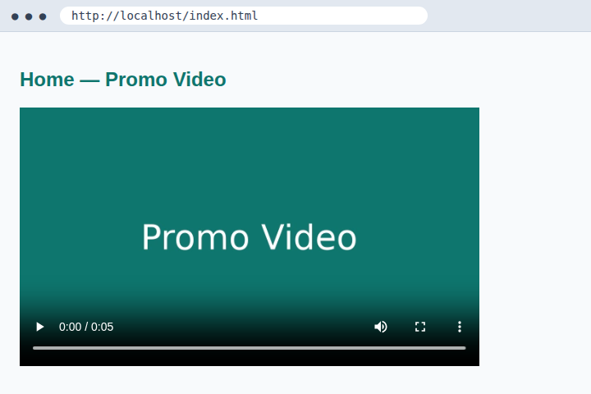
Output 1(a): Option B renders a playable video with controls (0:00 / 0:05)
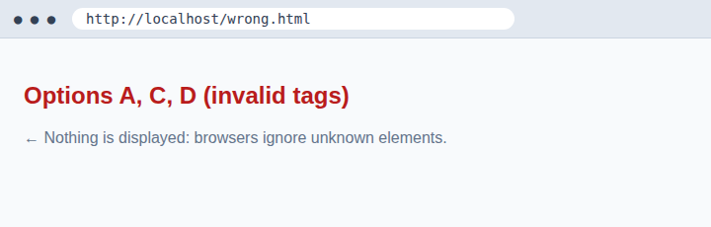
Output 1(b): Options A, C and D produce nothing – unknown tags are ignored
QUESTION 2
Identify the appropriate HTTP method for form submission
ANSWER  Option B | POST – the data travels in the request body, not in the URL, so credentials stay out of history, logs and bookmarks.

Why POST suits a registration form
- Form data is placed in the HTTP message body, so username, e-mail and password never appear in the address bar, browser history, server access logs or the Referer header.
- POST has no practical size limit (GET is restricted by URL length), so long inputs and file uploads work.
- POST is meant for actions that create or change data on the server, such as creating a new account. Pair it with HTTPS so the body is also encrypted in transit.
Comparison of the methods
Method | Purpose | Suitable for registration?
A GET | Retrieve data; parameters shown in URL | No – exposes password in URL and logs
B POST | Submit data in the body to create/process | Yes – hidden from URL, no size limit
C PUT | Replace/update an existing resource | No – not supported by HTML forms; used by APIs
D DELETE | Remove a resource | No – destructive; not a form action

Code used
<form action="/register" method="post">
<input name="username" value="asha">
<input name="email" value="asha@mail.com">
<input name="password" type="password">
<button>Register</button>
</form>
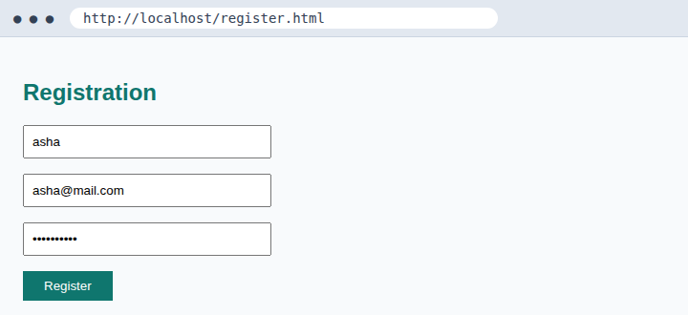
Output 2(a): Registration form with method="post"
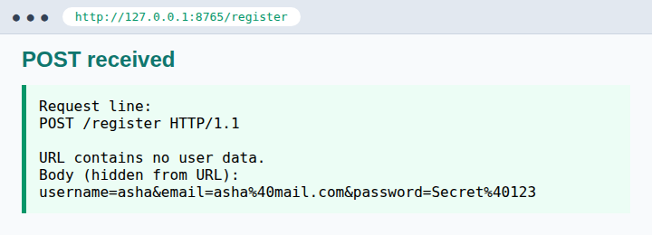
Output 2(b): Server response to POST – the URL is clean, data is in the body
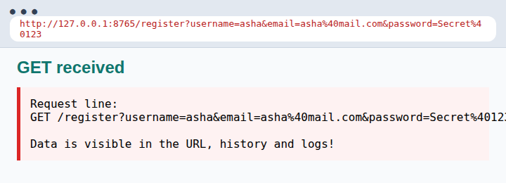
Output 2(c): Same form with GET – username, e-mail and password leak into the URL
QUESTION 3
Choose the proper semantic element for navigation
ANSWER  Option B | <nav> – the semantic HTML5 element that identifies a block of major navigation links.

Why <nav> is the right choice
- It describes the meaning of the content, not just its look. Browsers, search engines and screen readers recognise it as a navigation region.
- Assistive technology can jump straight to the menu (landmark navigation), improving accessibility; an aria-label can distinguish multiple navs.
- It makes the code cleaner and easier to maintain than a pile of anonymous <div> elements, and helps SEO.
Why the others are not suitable
Option | Element | Role
A | <div> | Generic container with no meaning (non-semantic)
B | <nav> | Navigation links – semantic
C | <section> | Thematic grouping of content, not a menu
D | <header> | Introductory content / logo area; may contain a nav but is not the menu itself

Code used
<header><h2>TechStart</h2></header>
<nav aria-label="Main navigation">
<a href="index.html">Home</a>
<a href="products.html">Products</a>
<a href="about.html">About</a>
<a href="contact.html">Contact</a>
</nav>
<main> ... </main>
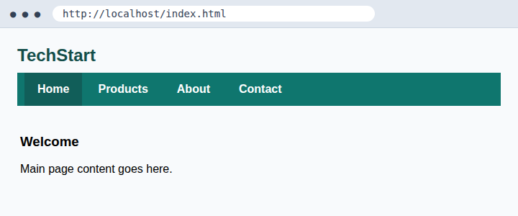
Output 3: Semantic page layout with <header>, <nav> and <main>, styled with CSS
QUESTION 4
Identify the correct XML syntax
ANSWER  Option B | <note><to>User</to><from>Admin</from></note> – the only well-formed document.

Rules satisfied by Option B
- Every start tag has a matching end tag, and tags are nested properly (last opened, first closed).
- There is exactly one root element (<note>) that wraps everything.
Errors in the other options
Option | Error | Parser message (xmllint)
A | Root <note> is never closed – missing </note> | Premature end of data in tag note
B | None – well-formed | No errors
C | <to> is closed with </from> – mismatched / improperly nested tags | Opening and ending tag mismatch: to and from
D | Closing tag </note is missing the final > | expected '>'

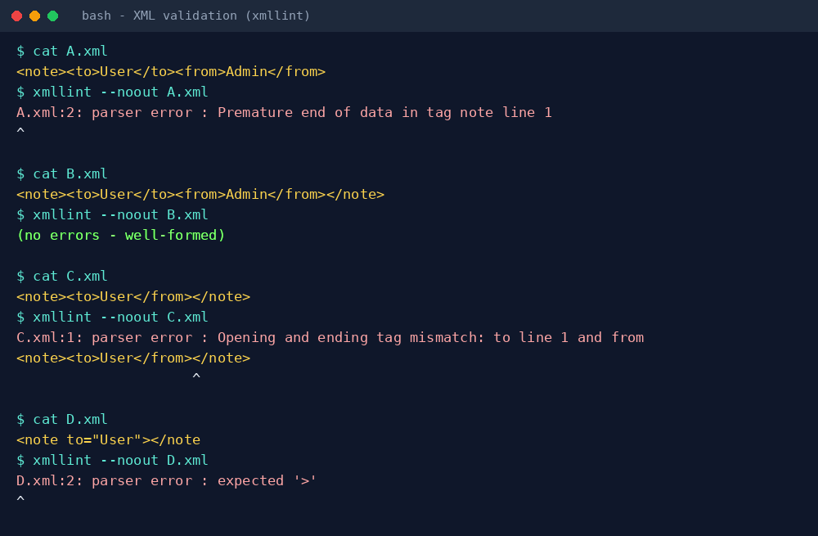
Output 4: xmllint validation – only B.xml passes; A, C and D report parser errors
QUESTION 5
Choose the correct protocol for web communication
ANSWER  Option B | HTTP (HyperText Transfer Protocol) – the application-layer protocol browsers and web servers use to exchange pages and data.

Why HTTP is correct
- HTTP follows a request–response model: the browser sends a request (method, URL, headers) and the server returns a status code, headers and the content (HTML, JSON, images, video).
- It runs over TCP (default port 80); its secure form, HTTPS, uses TLS on port 443 and should be used in production, especially for the registration form.
- It is stateless and supports methods such as GET and POST, which ties together Questions 1–3.
Why the others are not used for web pages
Option | Protocol | Real purpose
A | FTP | File transfer between hosts (ports 20/21)
B | HTTP | Web page and web-application communication
C | SMTP | Sending e-mail between mail servers
D | SNMP | Monitoring and managing network devices

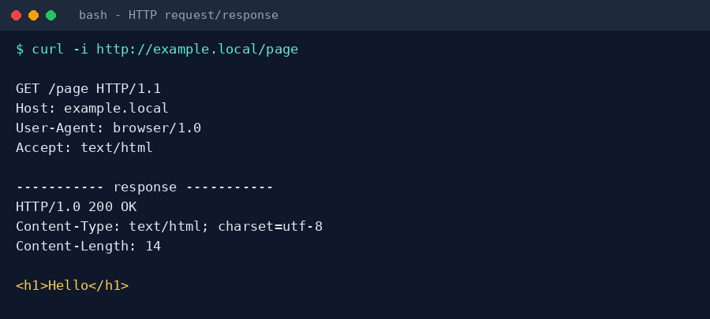
Output 5: A real HTTP request and response – 200 OK with Content-Type: text/html

